1. [Walmart logo.svg](https://en.wikipedia.org/wiki/File:Walmart_logo.svg)***Marketing Profile***

**A)** Walmart is the largest retail corporation of discount department and warehouse stores in the world. With a global footprint in 28 countries as of 2017, the company is able to offer a wide variety of merchandise and services to the public around the world at some of the lowest costs. The company is able to have full control on prices through selectivity with its suppliers and manufactures and aggressively demanding continuous cost reductions and improvements. With dominating influence in the overall world economy, the company has enough leverage to stir the markets in its favor, helping them achieve their mission.

**Products:** Dry and wet grocery, Beverages, Frozen food, Jewelry...etc.

**Services:** Photo processing service, Cellular service plan, Money order services.

**Location:** Today, Walmart operates approximately 11,500 stores under 56 banners in 27 countries and e-commerce websites in 10 countries Argentina, Central America, Chile, Mexico Canada, United Kingdom, Africa, China, Japan, and India.

**History of Walmart:**

Wal-Mart was founded in 1962 by Sam Walton in Rogers, Arkansas. It was run in a foundation of serving to customers at “lowest prices anytime, anywhere”. They focus on making a difference in the lives of their customers, and helping customers and communities save money and live better. In 1969, with more than 24 stores opened, the company officially incorporated as Walmart Stores, Inc.

Wal-Mart started its public trade on the New York Stock Exchange in 1972, recording sales of $78 million in its 51 stores. With the fast growth, Wal-Mart was operating in 11 states with 276 stores by the end of 70’s decade. In the 1980s, the first Sam's Club opened, serving small businesses and individuals, and the first Wal-Mart Supercenter opened. In the early 1990s, the company was the number-one retailer in the nation. Only one year after, it entered into the Mexican market, in 1995 in Canada, in 1996 in China, and by 1999 the company entered into the European Union by entering in the United Kingdom market.

In 2005, Wal-Mart made an effort when making a commitment on implement environmental measures to increase energy efficiency and announcing goals to be supplied 100 percent by renewable energy, create zero waste and to sell products that sustain people and the environment. Wal-Mart remained a global leader in the ensuing years, and in the 2010s it began to acquire numerous e-commerce businesses, including Jet.com (2016) and Moosejaw (2017). In 2018 the company changed its name to Walmart.

**B)**

**Main features of product and services:**

New technologies all showed up in Walmart stores across the country to deliver on a promise: Make shopping and working at Walmart easier for customers and associates alike.

* **Every Day low prices on a broad assortment - anytime, anywhere.**

Walmart provides a very large assortment of quality merchandise and services at affordable prices to its customers.

* **Grocery Pickup and Grocery Delivery**

Everyone who uses grocery pickup loves the way it combines the convenience of online shopping with the ease of never leaving the car. Also, Walmart's Grocery Delivery service provides great value, friendly service and fresh groceries on your schedule.

* **Walmart Pickup Towers**

In less than a minute, 16-foot Walmart Pickup Towers deliver millions of items from Walmart.com to your local Walmart store (without the cost of shipping).

* **Check Out with Me**

Outfitted with cellular devices and Bluetooth printers, associates complete the checkout process from anywhere on the sales floor, and provide a receipt via print, text or email.

* **Dotcom Store App**

Using their handheld devices, this technology gives associates the power to help customers shop Walmart.com if the item they’re looking for is out of stock.

* **Autonomous Shelf Scanner**

In 47 stores across the U.S., automated shelf scanners are giving associates more time to focus on serving their customers. They’re programmed to help identify where in-stock levels are low, prices are wrong or labels are missing – which in turn provides associates with a real-time view of store inventory, helping them quickly identify the areas of the store that need the most attention.

**C)**

**Organizational structure:**

* **Managers:** For each store, there are usually the store manager, 1 or 2 co-managers, and 4 or 5 assistant manager
* **Number of employees:** 2.2 million, Worldwide (2018) 1.5 million, U.S. (2017) - 700,000 International

**D)**

**Distribution:**

Apparently, Walmart utilizes the intensive distribution channel design or intensive distribution strategy, where Walmart Stores not only provide the same types of goods but also its employees function with the same roles and responsibilities. This applies to every store in the world.

Thus, the distribution/place element helps pull more customers and makes their shopping easy in terms of location.

* Walmart is a powerful ecommerce platform, which assists customers to buy products without the need of a physical location.
* Its organized distribution centers make it simple for stores to pick up the orders and deliver them directly to the customers.
* High-end IT systems allow the firm to trace the items regardless if they are in inventory or transit.
* Every Walmart outlet is strategically situated, especially in the United States so that the orders are delivered to the respective customers on time.
* Walmart has enormous delivery trucks to make door-to-door deliveries efficiently.

**Branding**

Among price-sensitive customers, Walmart is the brand of a retailer that provides the convenience of one-stop shopping for everyday products at the lowest possible price, because of its operational excellence, inventory management, and logistics infrastructure’.

Walmart’s brand identity is of a ‘low price discount retailer’. Right from the start, the company had employed a “national brand” strategy in its merchandising. By carrying all the well-known brands at relatively lower prices, it was able to demonstrate the superior value it brought to its customers.

**Marketing research:**

Walmart uses research like this in many areas of the world to decide the locations of their stores, because for a business as big and notorious as Walmart, they need to know where to open stores so they don’t lose money on any of their stores. This kind of research is important to Walmart because of the size of their corporation. They have already made their stores a better alternative for people looking for convenience and low prices, but in some places, Walmart would not be the favorite place to shop and when running a business like Walmart they need to place their stores according to the opinions of people in the area. Walmart went and asked people in New York City these questions to see if the customers of other stores would shop at Walmart if it were available there. Walmart did this research to see whether or not spending money to open a Walmart in New York City would be profitable.

**Promotion:**

The promotion element of Walmart is composed of **sales promotions**, **advertisements**, **public relations**, and **personal selling**.

* Walmart advertises on websites and newspapers. It utilizes sales promotions through discounts and special deals. This is the case for its digital platform.
* Personal selling, on the other hand, happens directly at its stores, where the sales persons persuade the buyers to try package deals or new products.
* For public relations, Walmart goes with press releases in order to inform its investors and customers about programs, strategies, and policies. Besides this, the firm also sponsors some charity programs occasionally, making it another significant element in its marketing mix to attract different customers.
* Walmart store uses popular slogans, which are connected to low prices. A few examples include “save money, live better,” “the lowest price store,” “everyday low price,” etc.
* It applies the strategy of “diversified advertising media” to promote. This includes from social media, billboards to TV ads and websites.

**E)**

Walmart has different operating divisions i.e. Walmart U.S, Walmart International, Sam’s Club and Global ecommerce and offer several retail formats with the help of these divisions. Walmart has achieved the mark of $534.7 billion revenue and known for everyday low pricing.

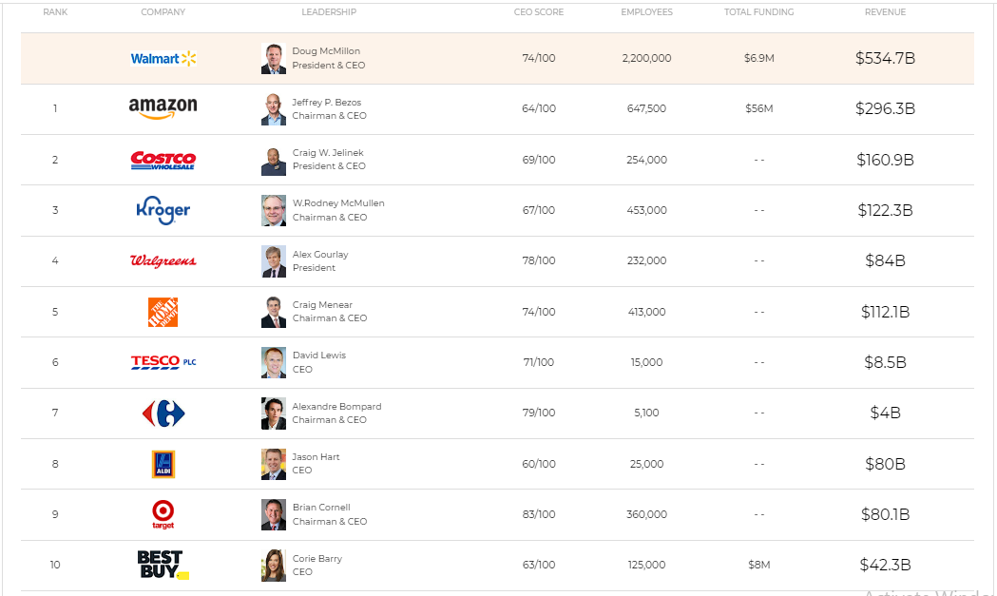Due to the expansion around the world, Walmart is also facing a lot of competitors in different countries through very different kinds of competition. The following table shows the top 10 competitors of Walmart in the retail industry and their revenues:

Now, let’s have an overview on the market strategies of the main competitors and how they can be a threat to Walmart in the market shares.

1. **Amazon**

Amazon is the largest e-commerce retailer founded by Bezos in 1994. Amazon is a Tech giant and top competitor of Walmart in the United States and outside China, India and many other places. It has several business segments i.e. online retail business, Amazon web services, digital stream and now looking for success in offline retailing.

Amazon.com dominates the U.S e-commerce market and grab almost 50% of the total online market sales. Amazon key competitive advantage is change and adaptability. The company has different segments and each segment contribute strong numbers to its revenue stream. Amazon is a constant threat to Walmart and forced it to redesign its e-commerce strategy.

1. **Costco**

Costco Wholesale Corporation is a multinational membership-only warehouse clubs. The total number of Costco membership warehouses is 770, out of which 531 warehouses are operating in United States, 100 in Canada, 39 in Mexico, 28 in United Kingdom and 4 in Puerto Rico, Japan and South Korea and Taiwan has 26, 15 and 10 respectively. The company has more than 94 million cardholders and memberships worldwide.

Costco primarily targets large families and businesses and offers bulk quality products at low prices. Costco is the key competitor of Walmart Inc. in the retail industry.

1. **Kroger**

The Kroger Co. is a multinational company founded in 1883 by Bernard Kroger and now one of the largest retailer in the world by revenue and the largest grocery store in the United States. The Kroger has more than 2764 retail stores – supermarkets, digital shopping options and multi-department stores – which operates through different formats directly or through its subsidiaries.

Kroger has a fierce competition with Walmart and other retail stores like Amazon and Aldi. According to a survey, every third American purchase from Kroger stores. Retail industry is very competitive and Kroger has been successful over the years to retain their customers’ trust.

1. **Walgreens**

Walgreens started its operations in 1901 as a drug store and founded by Charles Rudolph Walgreen. The company merged with Alliance Boots in 2014 and became Walgreens Boots Alliance, Inc. The American company hold one of the largest pharmacy store chain and operates 9560 stores in the United States. WBA is building its brand around Pharmacy, front end, health care and consumer services.

Walgreens is another Walmart competitor generated $131.5 billion revenue with a revenue growth of 11.3% in 2018. The company USA Division contributed 74% of the total revenue. Walgreen is committed to provide its customers a better health care and retail experience. One of the key measures was the relaunch of Walgreen brand as “Trusted since 1901” based on three main ingredients trust, care and accessibility.

1. **The Home Depot**

The Home Depot Inc. is known for home improvement products and sells tools, hardware, gardening equipment and plants, construction products and services. It is the largest home improvement retailer in the world. The company total number of employees are 400,000 and operating more than 22,000 stores in the United States, Mexico and Canada. The company offers 35,000 in-store products and more than 1 million products online. The Home Depot a strong competitor of Walmart and Amazon in both offline and online retail industry.

1. **Tesco PLC**

Tesco is serving its customers since 1919. It is a British grocery and mechanize retailer and it’s headquarter is located in Hertfordshire, England, United Kingdom. It has 450,000 employees and more than 6800 shops around the world. In addition to Tesco grocery operations in UK and Europe, it is also operating China, Thailand, Malaysia and India.

In UK retail grocery market, Tesco is the major competitor of Walmart ASDA. In 1999 Walmart acquired ADSA Group Ltd for $10.8 billion. ASDA retail network has a huge presence in UK and has prominent market share in the UK retail industry.

1. **Carrefour S.A**

Carrefour is a well-known French retailer founded in 1958. This retail brand has a global presence and operates in Europe, The American, Asia and Africa where it serves millions of customers. The company operates hypermarkets, supercenters, Cash & Carry, Warehouse Clubs, Discount stores and super markets. Carrefour means Crossroad and it’s headquartered in Billancourt, France. The company has 12,300 stores and e-commerce websites in 30 countries and regions.

1. **Aldi**

Aldi has more than 1,800 stores in 35 states and is focused on growing in the Midwest, the Mid-Atlantic, Florida and California. It’s on track to become America’s third largest supermarket chain behind Walmart and Kroger, with 2,500 stores by the end of 2022.

The competitive advantage for Aldi is about the strategy they adapt. The first one is the private label productions, which is different with Walmart that might be the key to attract customers. The other one is the size of the shop places, which is much smaller than the supermarket. The size of the Aldi could save time for shoppers by reducing the shopping time, because they do not need to spend time on walking and selecting various brand of the same productions.

1. **Target**

Target is another well-known retail brand and one of the key Walmart Competitor. One of the largest retailer in the United Sates, it was founded in 1902 by George Dayton and headquartered in Minneapolis. Target has 1851 stores operating in the United States. The company has 360,000 employees globally.

Majority of revenue is generated from food and beverage, clothing and beauty and households product. Both Target and Walmart are strong competitors in the U.S Retail Industry. Both has a significant neighborhood stores and also started e-commerce sales through websites. Target Corporation e-commerce sale contributed US$5 billion to its revenue stream. This performance is a huge threat to Walmart and Amazon.com.

**10) Best Buy**

Best Buy is the largest consumer electronics retailer in the United States. The company competes aggressively on price with such rivals as Costco Wholesale, Sam’s Club, Walmart, and Target, but it is also known by consumers for its first-rate customer service. Best Buy customers have commented that the retailer’s sales staff is exceptionally knowledgeable about the company’s products and can direct them to the exact location of difficult-to-find items. Best Buy customers also appreciate that demonstration models of PC monitors, MP3 players, and other electronics are fully powered and ready for in-store use. Best Buy’s Geek Squad tech support and installation services are additional customer service features that are valued by many customers.

1. ***Marketing process****:*

**A)** Yes it does, Walmart’s largest strength is the expansive network of distribution centers and stores. Stores are geographically placed strategically so 90% of the U.S. population is within 10 miles of a Walmart store. Walmart boasts more than 150 distribution centers and is the main hubs of its business. Its distribution operation is world’s one of the most prominent activities, servicing clubs, direct deliveries, and stores to the customers.

1. ***Opinion****:*

**A)** The complete performance of Walmart in the international retail market is associated with its marketing strategies. Walmart’s main strategy is summed up in its widely advertised mission statement and slogan: "*We save people money so they can live better*.” making it one of the key customer-centric approaches to be a market leader consistently. Now, this strategy supports its generic business plan, which is none other than “cost leadership.” Yes, the company has lower prices and lower costs but the high sales volume enables Walmart to obtain bigger profits.

**C)** Marketing is the process of getting people interested in your company's product or service. This happens through market research, analysis, and understanding your ideal customer's interests. Marketing pertains to all aspects of a business, including product development, distribution methods, sales, and advertising. Anything that you use to communicate with your customers in a way that persuades them to buy your products or services is marketing, including advertising, social media, coupons, sales, and even how products are displayed.

There are three primary purposes of marketing:

* Capturing the attention of your target market.
* Persuading a consumer to purchase your product.
* Providing the customer with a specific, low-risk action that is easy to take.

The marketing process begins with the idea for your product and continues until that product is in the hands of a consumer who bought it. Even after a customer has made a purchase, your marketing shouldn't end—a portion of your advertising should be targeted at current customers to ensure they remain customers and increase loyalty.